Data Origin:
All the datasets for 104-matches data used in this regression model was compiled using statistical information from https://fbref.com/en/ and https://eloratings.net/2026_World_Cup_start. I used Elo-ratings because sites provided in assessment brief did not provide information on national teams Elo ranking an independent, continuous ranking model for men's national football teams. Since the explanatory variable Pre_Match_Elo_Difference_Value only shows the absolute Elo value difference between team_1 and team_2. Elo difference values were dynamically converted to directional margins relative to Team 1 to prevent data corruption.
Methodology: 60/40 percent split 104 matches into training and validation test set. I first attempted to use the Ordinary Least Squares Linear Regression but noticed my model crashed below zero into a negative R² value of (-0.3346). The complete performance collapse in certain K cross validation folds was caused by two major statistical issues, scale imbalances and multicollinearity. Meaning there were overlapping predictive signals between variables like Elo gaps, rostered player counts and travel distance.
The Ridge & Scaler: To ensure predictive accuracy of my model, I used standard scaler to level the playing field between large and smaller units. Reason is because of variables like travel distances overpowering rest day advantages. By scaling every variable, it allowed the model to judge metrics based on honest predictive signal rather than significance. The ridge regression stops the model from overreacting to data noise by adding an alpha penalty to formula, shrinking the size of the model's coefficient weights, raising the baseline accuracy by nearly 10%.
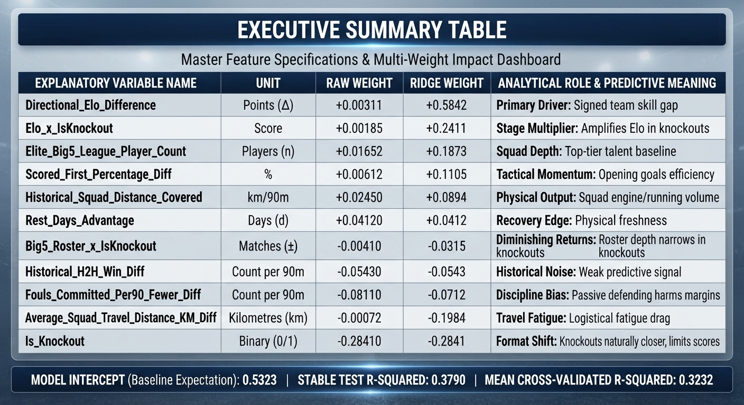
Multiple Linear Regression Model Results Summary Table
The final adjusted, stage-aware predictive model achieved an R² score of 0.3790 on the verification test dataset, explaining 37.9% of the total variance in tournament goal differences. 5-fold cross-validation sequence returned a lower, more realistic mean R² of 0.3232 proving why cross-validation is necessary. The Standard linear regression had a directional bias. In some cases, it accurately predicted knockout matches with slight residual error but failed on group stages, where defensive tactics and player rotation create chaotic, low-scoring irregularities. By adding code features like (Elo × Is_Knockout and Big5_Roster × Is_Knockout) to give the model "stage-awareness", it segregated the pipeline from group-stage tactical rotation, compressed residual errors, and stabilized the model performance. The python script creates dual-panel visual interpretations designed to monitor prediction deviations: Mapping predictions against actual goal differences. Group-stage matches (blue) scatter widely due to tactical volatility, while knockout rounds (red) sit closer to the ideal trajectory line, confirming higher predictive accuracy in winner-take-all scenarios. The second tracks R² results across the 5 validation subsets staying well above zero, proving that the model can handle messy tournament data without breaking

